12/17/2023

Sanskruti Shimple

Trainity

**Instagram User Analytics**

**Instagram User Analytics  
SQL Fundamentals**

###### **Description:**

Imagine you're a data analyst working with the product team at Instagram. Your role involves analyzing user interactions and engagement with the Instagram app to provide valuable insights that can help the business grow.  
User analysis involves tracking how users engage with a digital product, such as a software application or a mobile app. The insights derived from this analysis can be used by various teams within the business. For example, the marketing team might use these insights to launch a new campaign, the product team might use them to decide on new features to build, and the development team might use them to improve the overall user experience.  
In this project, you'll be using SQL and MySQL Workbench as your tools to analyze Instagram user data and answer questions posed by the management team. Your insights will help the product manager and the rest of the team make informed decisions about the future direction of the Instagram app.  
Remember, the goal of this project is to use your SQL skills to extract meaningful insights from the data. Your findings could potentially influence the future development of one of the world's most popular social media platforms.  
  
**Project Overview:**  
This project delves deeply into analyzing user interactions and engagement within Instagram using SQL via MySQL Workbench. The primary aim is to derive actionable insights pivotal for strategic decision-making across diverse teams like marketing, product development, and investor relations within the Instagram ecosystem.  
  
**Approach:**  
Initiating the creation of a robust database using provided commands ensured data accuracy and relevance. Employing MySQL Workbench, a methodical approach addressed each task outlined in the project guidelines. This encompassed structured SQL queries to extract relevant information accurately and efficiently.

**Technology Stack:**  
MySQL Workbench was chosen for its comprehensive functionality in managing databases and executing SQL queries effectively. Its user-friendly interface and compatibility with MySQL databases ensured seamless data analysis and extraction of insights, ensuring precision and efficiency in handling Instagram user data.

SQL Tasks :  
**A) Marketing Analysis:**

**1. Loyal User Reward:**The marketing team wants to reward the most loyal users, i.e., those who have been using the platform for the longest time.  
  
**Your Task:** Identify the five oldest users on Instagram from the provided database.  
  
**Solution:**Code:SELECT * FROM users

ORDER BY created_at

LIMIT 5;  
  
Output:

**2. Inactive User Engagement:** The team wants to encourage inactive users to start posting by sending them promotional emails.  
  
**Your Task:** Identify users who have never posted a single photo on Instagram.

**Solution:**Code:  
SELECT username  
FROM users  
LEFT JOIN photos  
ON users.id=photos.user_id  
WHERE photos.id IS NULL;

Output:

**3. Contest Winner Declaration:** The team has organized a contest where the user with the most likes on a single photo wins.  
**Your Task:** Determine the winner of the contest and provide their details to the team.

**Solution:**Code:  
SELECT username  
username, photos.id, photos.image_url, count(likes.user_id) AS total  
FROM photos  
INNER JOIN likes  
ON likes.photo_id = photos.id  
INNER JOIN users  
ON photos.user_id = users.id  
GROUP BY photos.id  
ORDER BY total DESC  
LIMIT 1;  
  
  
Output:

**4. Hashtag Research:** A partner brand wants to know the most popular hashtags to use in their posts to reach the most people.  
**Your Task:** Identify and suggest the top five most commonly used hashtags on the platform.

**Solution:**Code:

SELECT  
tags.tag_name, COUNT(*) AS total  
FROM photo_tags  
JOIN tags  
ON photo_tags.tag_id= tags.id GROUP BY tags.id  
ORDER BY total DESC  
LIMIT 5;

Output:

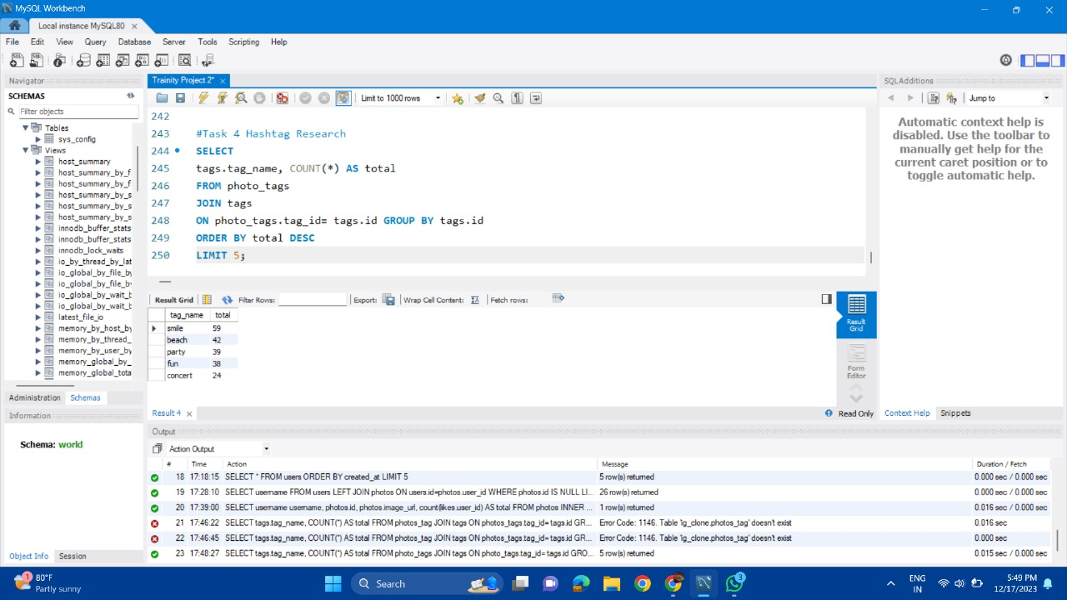

5. **Ad Campaign Launch:** The team wants to know the best day of the week to launch ads.

**Your Task:** Determine the day of the week when most users register on Instagram. Provide insights on when to schedule an ad campaign.

**Solution:**Code:

SELECT  
DAYNAME(created_at) AS day, count(*) as total  
FROM users  
GROUP BY day  
ORDER BY total DESC   
LIMIT 2;

Output:

**B) Investor Metrics:  
  
1. User Engagement:** Investors want to know if users are still active and posting on Instagram or if they are making fewer posts.

**Your Task:** Calculate the average number of posts per user on Instagram. Also, provide the total number of photos on Instagram divided by the total number of users.

**Solution:**Code:

SELECT  
(SELECT COUNT(*) FROM photos) / (SELECT COUNT(*) FROM users) AS avg;

Output:

**2. Bots & Fake Accounts:** Investors want to know if the platform is crowded with fake and dummy accounts.

**Your Task:** Identify users (potential bots) who have liked every single photo on the site, as this is not typically possible for a normal user.

**Solution:**Code:

SELECT user_id, COUNT(*) as num_likes  
FROM likes  
GROUP BY user_id  
HAVING num_likes= (SELECT COUNT(*) FROM photos);  
SELECT u.username, COUNT(*) as num_likes  
FROM users u  
JOIN likes l ON u.id = l.user_id;  
GROUP BY u.id  
HAVING num_likes = (SELECT COUNT(*) FROM photos);

Output:

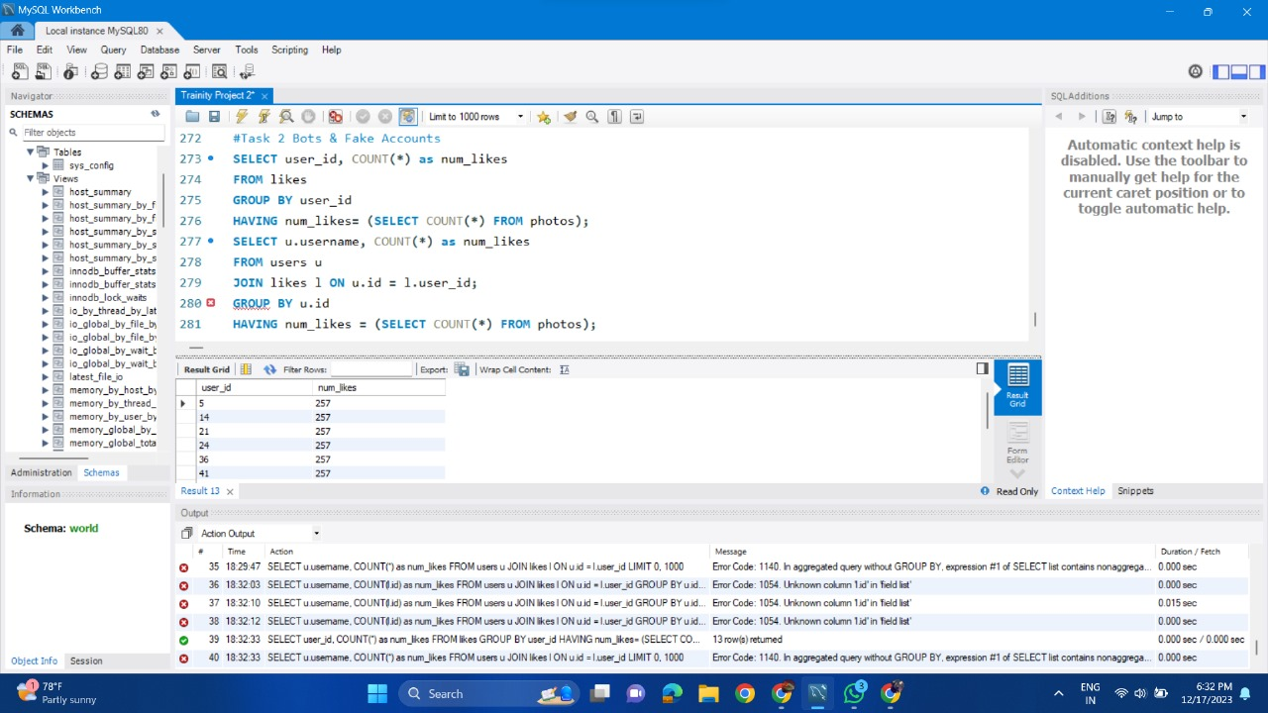

**Insights Derived:**The meticulous analysis yielded notable insights. Identifying the five oldest Instagram users sheds light on user loyalty and engagement patterns. Spotting inactive users who hadn’t posted provided opportunities for targeted re-engagement strategies.

Determining contest winners based on likes highlighted user engagement's significance and showcased influential figures within the platform. Identifying the top five most used hashtags offered valuable insights for partner brands seeking broader audience engagement.

Understanding user registration patterns facilitated the scheduling of effective ad campaigns.

**Achievements:**

This project met its objectives by delivering actionable insights derived from Instagram user data. Compiled findings aim to empower leadership in making informed decisions, potentially enhancing user engagement, refining marketing strategies, and contributing to overall platform growth.

The impact lies in shaping the future of a premier social media platform. Insights derived serve as a cornerstone for strategic planning, enabling tailored approaches to user engagement, content creation, marketing campaigns, and platform enhancements.

**\*\*\***